The Southern Border Terrier Club Championship Show 9th June 2018
Judge Mr W Shorthose (Cundytyke)
189 Dogs 195 Entries

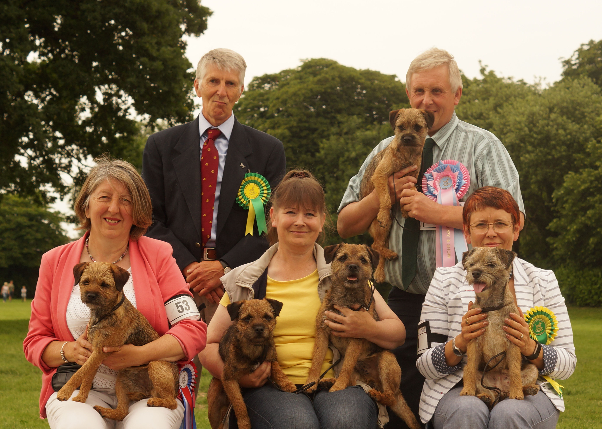
From Top Left
Judge Mr W Shorthose (Cundytyke), Best PuppyIN Show & Best Puppy Bitch Onthill Daydreamer,
Best Opposite Sex & Bitch CC CH Benattivo Fire Flower JW, Best In Show Blewecourt & Dog CC Zeus by Badgerbeck, Reserve Best In Show & Reserve Dog CC CH Badgerbeck Uncle Fester
Reserve Bitch CC & Best Veteran CH Cobstoneway Moon River at Clipstone

Full Resuts & Critique

It is always a particular honour to judge a Breed Club Championship Show and my thanks go to the committee for their hospitality and my stewards who kept things running smoothly.

I found only two poor mouths but more had wrong, thin skins and some needed to go home for a good feed. A working terrier needs to be correctly muscled and too many needed nourishment and exercise. The biggest problem, however, remains poor front movement showing both incorrect shoulders and, for some, over angulation in the hindquarters.

Best In Show & Dog CC Blewecourt Zeus by Badgerbeck
Reserve Best In Show & Reserve Dog CC CH Badgerbeck Uncle Fester
Best Opposite Sex & Bitich CC CH Benattivo Fire Flower JW
Reserve Bitch CC & Best Veteran CH Cobstoneway Moon River at Clipstone
Best Puppy In Show & Best Puppy Btich Onthill Daydreamer
Best Puppy Dog Heading For Home At Moleschamber

Puppy Dog
Entries 4 Absentees 2

1st Dassett Last Waltz (Mrs S Spafford) Had more substance than 2nd without being overly large. Head still developing, good reach of neck, fair topline and good tailset. Good feet and moved OK
2nd Onthill Nighthawk (Mr V J & Mrs M Pearce) Not the head shape of 1st and weaker jaw. Lacked both the overall strength and muscle which one would hope to see.

Puppy Dog
Entries 8 Absentees 1

1st Heading For Home At Moleschamber (Mrs L Pile) Only six weeks older than winner of previous class and much more mature. Good size and easily spanned. Good shape to head with only slight stop, well set ear and well set on neck. Correct length to the body and brought hind legs well under on the move.
2nd Borderstream Zodiak (Mr & Mrs S Ward)
Similar in type to 1st and liked his reach of neck and body shape. Needs to be exercised and to be built up a bit more.
3rd Otterbobs Marquis (Mr J R & Mrs H Gilpin) Head still developing, still very much the baby. Had a really good coat and pelt and moved well with drive from behind. Only lost out on maturity and I would like to see him again in the future.
Res Tojamatt Taboo (Mr & Mrs D Matthews)
VHC Twigglestone Steps To Heven (Mrs L I Aldous)

Junior Dog
Entries 8 Absentees 0

1st Earthtaw Jasper Carrot At Moleschamber (Ms L Pile) Good proportions to head, not overly strong. Pleasing reach of neck and angles in the shoulder. Correct shape to ribs and strong loin. Evident muscle in hindquarters and moved positively.
2nd Brackenfell Rock The Boat For Vandamere (Mr S Pollit) Spannable though bigger all through than 1st. Great coat and skin. Stood on good feet and moved soundly, keeping his topline.
3rd Dandyhow Captain Morgan (Mrs K Irving) Handy sized dog with a decent stride. Moved OK. Lacking coat on the day.
Res Brackenfell Born To Be Alive (Mr I Single)
VHC Borderstream Zodiak (Mr & Mrs S Ward)

Yearling Dog
Entries 5 Absentees 0

1st Brackenfell Rock The Boat For Vandamere (Mr S Pollit)
2nd Remony For A' That (Mrs A E Gregory) Moved soundly. Narrow front and good length of body but comes to hand balanced. Correct coat and loose skin. Slower maturing type.
3rd Tufterslodge Tea N Cake (Mrs J M Phipps) Thicker all through than others. Appears shorter in neck and not quite the lay back of shoulder. Strong hindquarters and had drive from behind on the move.
Res Kyscafter Equinox (Miss M Newman)
VHC Brackenfell Born To Be Alive (Mr I Single)

Novice Dog
Entries 6 Absentees 1

1st Dassett Last Waltz (Mrs S Spafford)
2nd Tojamatt Taboo (Mr & Mrs D Matthews) When on the move, good enough behind but hadn’t the same reach in front. Good topline and tailset.
3rd Twigglestone Steps To Heven (Mrs L I Aldous) Good size, not too big. Fair head with good ear set. Lacked coat today.
Res Ragatam Talk Talk (Miss T Peacock)
VHC Kirk Keld Rambler At Hollyfell (Mr M Giles)

Post Graduate Dog
Entries 5 Absentees 1

1st Moleschamber Finlaggan (Mr B Dennis) Pleasing, correct shape to the head, some being too long in the muzzle. Correct size and balanced when standing and in the hand. Good reach of neck and correct angles in the shoulder. Moved soundly on good feet.
2nd Onthill Pathfinder (Mrs A J Osler & Mrs J E Nadian) Bit smaller than others in the class but balanced. Could move with a bit more drive from behind.
3rd Brewbrads Tricky Trickster (Miss V Bradley) Not a very typical head, lacking strength in the muzzle. Good blue/tan coat and thick pelt. Feet a bit flat and overall, a size too much.
Res Roxambor Space Invader (Mr B J & Mrs A E Read)

Mid Limit Dog
Entries 5 Absentees 1

1st Otterpaws Muninn (Mr & Mrs G Birrel) Nice size of dog. Good head and neck. Liked the construction behind allowing him to move with drive, clearly moved best in the class.
2nd Tarkaswell Smart Move To Otterwood (Mr M J & Mrs J M Hollingsbee) Straighter in front than 1st. Shown in good coat and not a bad size. Had rather flat feet and would benefit from some roadwork.
3rd Roxambor Magical Timepiece ShCM (Mr B J & Mrs A E Read) Stands well but appears a bit big and comes up heavy in the hand. Moved a bit wide behind.
Res Orangebox Dark Energy (Mr M & Mrs T Anscombe)

Limit Dog
Entries 18 Absentees 3

1st Blewecourt Zeus by Badgerbeck (Miss L M Jenkins) Neatly put together dog who has all the essentials. All is in balance. Narrow in body but with both appropriate length and strength. Good reach of neck and sloping shoulder. Shown in good coat and had a realy good thick, loose skin. Dog CC and Best in Show
2nd Tarkaswell Dr Zhivago At Moleschamber ShCM (Ms L Pile) Smart, upstanding dog though appears a bit straighter in shoulder than 1st. Narrow enough in body and had good coat and pelt. Moved well behind.
3rd Oakyard Out N'about At Dassett (Mrs S Spafford) Bit short of coat today. Hadn’t quite the drive from behind of some when on the move. Good bone and stood on good feet.
Res Clipstone Starshine (Miss E & Mrs J Jackson)
VHC Tojamatt Rhythm N'blues at Raedwulf (Mr M & Mrs V Atkinson)

Open Dog
Entries 13 Absentees 5

1st CH Baillieswells Glengyle At Glebeheath JW (Mrs J Guvercin) Good head, with breadth of skull and short, strong muzzle. Neat ear, well set on. Good reach of neck and sloping shoulder. Strong in the loin and moved positively.
2nd Dandyhow Galloping Gourmet JW (Mrs K Irving) Typical head, well set on. Good shape and size of body. Moved soundly with drive from behind while keeping his topline.
3rd Howthwaite Grainsgill (Mr R J & Mrs E A Barrett) Another to like a lot from this class. A bit stronger in front as he has a bigger frame. Shown in really good coat and pelt. Correct driving movement.
Res Gameway Mcvitie JW (Mrs P Clark)
VHC Cobstoneway Ocean Sunrise (Mrs G Stevens)

Veteran Dog
Entries 7 Absentees 2

This was the class with, consistently, the best movers.
1st CH Cobstoneway River Magic JW ShCM (Miss C Spencer) Really liked his overall make and shape. A masculine head without exaggeration, strong muzzle and shallow stop. Positive, true movement and shown in first class coat.
2nd CH Lairehope Lord of the Glen At Tweedburn (Mrs C Archibald) Similar comments to 1st apply. Shown in really good coat and moved true with little effort.
3rd Beaconpike Red Saturn (Mr S & Mrs K Golding) Little bit bigger than those placed above. Really strong head of good ‘otter’ shape and slight stop. Moved with good length of stride showing his correct basic construction.
Res Onthill Super Trouper (Mr R & Mrs A M Ramus)
VHC St Bedehounds Frank in Sense of Raleniro ShCM (Mr M J & Mrs D A Lorraine)

Special Open Working Dog or Bitch
Entries 3 Absentees 0

1st CH Badgerbeck Uncle Fester (Miss L M Jenkins) Clear winner of this class with all the essentials. Good head with strong jaw. Reach of neck runs into well laid back shoulders. Narrow enough and spannable. Strong loin and good angulation in hindquarters. Moved soundly. Reserve Dog CC
2nd CIB CH FR/IT/CRO/SLO/RSM Stonechester Apostraphe Von Jrasamuyr MFH (Miss C Khatchikian) Wider in front and, for her size, comes up heavy in the hand. Ok in head and neat ear. Good coat though feet a bit flat.
3rd CIB CH FR/IT/CRO/SLO Stonechester Question Von Jrasamuyr MFH (Miss C Khatchikian) Not the quality of the winner as a too big and comparatively stuffy in the neck. Moved OK.

Minor Puppy Bitch
Entries 8 Absentees 4

1st Onthill Daydreamer (Mr R & Mrs A Ramus) Nice bitch with good head and reach of neck. Well laid shoulder and ribs carried well back. Well constructed behind and moved best. Best Puppy In Show
2nd Oxcroft Lizzy (Mr J Price) Clear otter shaped head, good front and length of body. Toline OK when standing but she was unsure of herself on the move. Needs to overcome shyness.
3rd Crazy Train And I Love Her (Miss A K Jiderlund) Not quite steady on the move nor the reach of neck of others. Quite deep in chest. Good coat
Res Laurelton Susie's Surprize (Mrs L Culliford)

Puppy Bitch
Entries 10 Absentees 4

1st Twigglestone Somethin Else For Lessien (Miss S J Pateman) Neat bitch who moved soundly. Well angulated both in shoulder and hindquarters. Bit short of coat today but basics present.
2nd Glebeheath Fingers On Lips (Mrs J Guvercin) Appeared more upright though fair neck and lay back of shoulder. Good size but needed to settle on the move. One to look forward to in the future.
3rd Esyntona Codeword Vandamere (Mr M & Mrs V Atkinson) Another of good size and with a keen expression. Moved Ok but not the harshness of coat of the others.
Res Ragatam Chit Chat (Miss T Peacock)
VHC Aldamar's Joy Division (Dr M D McCall)

Junior Bitch
Entries 13 Absentees 2

1st Earthtaw Jessica Rabbit (Miss J A & Mr M W V Haydon & Gibbings) Up to size, good head and strong jaw. Narrow front and good topline and tailset. Bit short of coat today.
2nd Southash Hazel Honey (Mr J & Mrs I M Southam) Bit smaller all through than those placed either side. Good shape to body with ribs carried well back. Moved soundly.
3rd Picer Beth Chatto JW (Mr G & Mrs S Pickering) Another sized up, strong head and heavier in bone than some. Good dense coat and loose skin. Moved Ok.
Res Onthill Crystal Rock (Mr R & Mrs A Ramus)
VHC Rhozzum Whim (Mrs M Sharp)

Yearling Bitch
Entries 7 Absentees 3

1st Oakyard On Song JW (Mr J Parry) Liked her a lot as all qualities are there. Pleasing head with enough strength to muzzle and good ear set. Moved with purpose showing drive from behind.
2nd Achnagairn Touch Of Class (Mrs A Fraser) A bit thicker all through but fair reach of neck. Stands on good feet and moved Ok. Short of coat but thick, loose skin.
3rd Amber Spirit Gambler (Ms S P Greenway) Not the head shape of those placed above. Deep enough in chest and straighter in front consequently not the same freedom of movement or stride length.
Res Borderstream Maisey (Mr & Mrs S J Ward)
VHC Thistlemead Harmony (Mrs P M Heeley)

Novice Bitch
Entries 10 Absentees 7

1st Ragatam Chit Chat (Miss T Peacock) Blue/tan puppy who moved Ok. Time still on her side to develop.
2nd Thistlemead Harmony (Mrs P M Heeley) Not quite the same quality as 1st. Movement not so true or positive and short of coat on the day.
3rd Badgerbeck Dance the Blues (Mr M Giles) Appears on the leg and not so well balanced. Bit wide in front for me and lacked drive when moving.

Post Graduate Bitch
Entries 12 Absentees 3

1st Beaconpike Venus (Mr S R & Mrs K M Golding) Really good size and all in proportion. Strong head and good reach of neck. Hindquarters propelled her with drive as good angulation present. Holds her topline.
2nd Comberdown Shenanigans (Mr I & Mrs A Higham) Bit bigger all through but still in balance. Stands four square and moved well. Good length of flexible body. Coat on the blow today.
3rd Hartleycoop Sula By Onthill (Mr R & Mrs A Ramus) Another nice one, similar in type to 1st but didn’t move with the drive or animation of winner.
Res Achnagairn Tutti Frutti (Mrs A Fraser)
VHC Rhozzum Gwenno (Mrs M Sharp)

Mid Limit Bitch
Entries 9 Absentees 4

1st Dowgri Demelza ShCM (Mr W & Mrs T J Baird) Lots to like here. Tall enough but balanced and spannable. Good head and shoulder. Stands on good feet and has good topline and tailset.
2nd Foxpaw Revelation JW (Mrs H Fulker) Very feminine expression. Good coat and skin. Moved with sufficient drive.
3rd Shiftyfox Fairydust Of Glenoak (Dr J A & Mrs E J Hudson) Deep enough in chest and heavier buit in front, coming up heavy in the hand. Would like a bit more drive from behind when moving.
Res Twigglestone Elfenor JW ShCM (Mrs L I Aldous)
VHC Benattivo Good News For Barterhound (Mrs B B Roderick)

Limit Bitch
Entries 12 Absentees 3

Really good class with any of those placed likely to change places another day.
1st Comberdown Stitch (Mr I & Mrs A Higham) Very pleasing head with strong muzzle and neat set of ear. Well angled front assembly and good length to the body. Strong loin and well muscled thigh. First class coat.
2nd Glebeheath Maiden Name At Oakyard (Mr J Parry) A shade smaller than the winner, neat and feminine. Well balanced all through. Good feet and moved with drive.
3rd Remony Frosted Ivy JW ShCM (Mrs A Gregory) Shown in quite profuse coat today, not helping to assess shape until handled. Like the length of body and way ribs are carried back. Positive on the move.
Res Badgerbeck The Masher (Miss L M Jenkins)
VHC Achnagairn Prim N'proper (Mrs A Fraser)

Open Bitch
Entries 15 Absentees 9

1st CH Benattivo Fire Flower JW (Mrs S J & Mr C P Girling) Nothing exaggerated, well balanced all through. Feminine head with sufficient strength to it. Really liked the angles from the hip through the hind legs allowing her to move with drive and a good length of stride. Bitch CC and Best Opposite Sex
2nd CH Otterbobs Xolana (Mr J R & Mrs H Gilpin) Another I liked a lot and similar comments apply. Shown in first class correct coat. Hard decision between first two.
3rd Brankell Double Or Quits JW (Mr P Brannan & Miss M Kelly) Slightly stronger in head and neck and a bit wider in front. Good topline and tailset. Shown in good coat.
Res CH Ploughdown Persephone (Miss C Spencer)
VHC NORD UCH Crazy Train Cranberry SE JV-15 (Miss A K Jiderlund)

Veteran Bitch
Entries 9 Absentees 3

1st CH Cobstoneway Moon River at Clipstone (Miss E & Mrs J Jackson) Good head and mouth and well arched neck showing lay back of shoulder. Not thickened as she matured. Shown in really good coat with a thick skin. Reserve Bitch CC & Best Veteran
2nd Beaconpike In A Storm (Mr S & Mrs K Golding) Not quite the strength of head of 1st. Good size and moved soundly with positive drive from behind. Preferred the
shape of the body
3rd Beaconpike Night Sky At Brackenfell (Mr C Hall & Miss L Ellis) Ok in head and neck. Very showy in profile with good topline but not as positive on the move.
Res CH Howthwaite In Violet (Mr R & Mrs E Barrett)
VHC CH Nantcoch Ffion JW ShCM (Mrs J M Phillips

